Summer 2013 Mr. McGowan
AP Calculus AB Minuteman Tech
Quiz 14 – Surface Area

1) Use the Cylindrical Shells method to find the volume of the solid generated when the area enclosed by

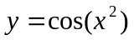, x=0, y=0, and 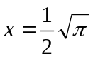

is rotated about the y-axis.

(Sketch the area and show all your steps for partial credit)

2) Use the formula 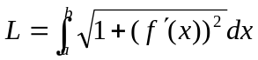 to find the length of the curve y=2x-3 from x=1 to x=4.

3) Use the formula 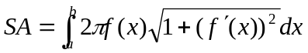 to find the area of the surface generated when the curve y=-2x+6 from x=-1 to x=3 is rotated about the x-axis.

